**Project 6 Coin Detection – Part 2 complete**

Name: Arnav Jain Period: 3 Date: 03/13

Did you name your file l062.cpp (Lower case L, then 062)? yes

Did you create the edge matrix? yes

Did you create the gradient direction matrix? yes

Did you create the imagev.ppm (visual of votes)? yes

Did you use Bresenham's line algorithm for voting? yes

Does your application create coins.ppm file? yes

Does you code display on the screen and in results.txt a summary of your results? yes

Did you test your code on terminal/gnu linux in c++11? yes

Run your code (the same code you submit) on the 3 images I provided (easy, medium, hard) then paste here the following:

* The initial image ( the one I provided), the imagev.ppm, coins.ppm you obtained running your code, copy paste here the content of your results.txt file your code created
* **Note: my -TCircle takes in a ratio in range 0 to 1, as it calculates the ratio between the actual points on the circle with radius r / total possible points on a circle with radius r**

1. For the easy image:

Command line including all parameter values used for this image:

\l061 -L 60 -U 120 -TC 170 -F image.ppm -TCircle 0.1

Initial image:

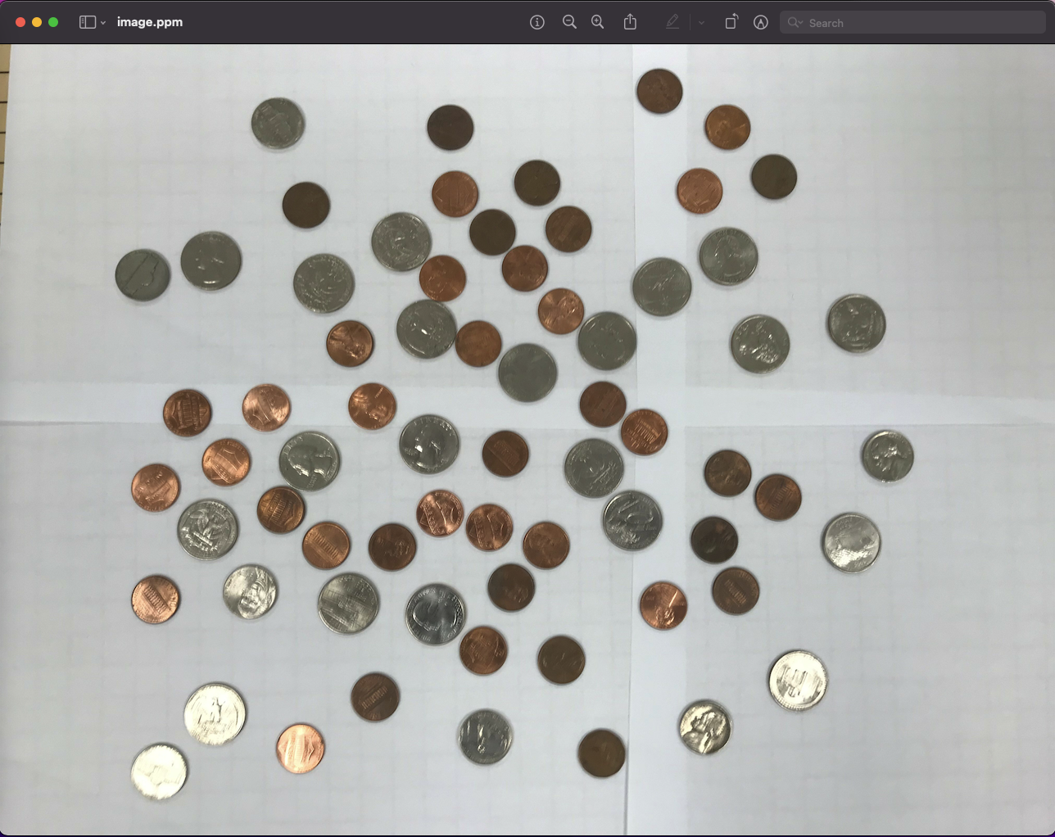

imagev.ppm:

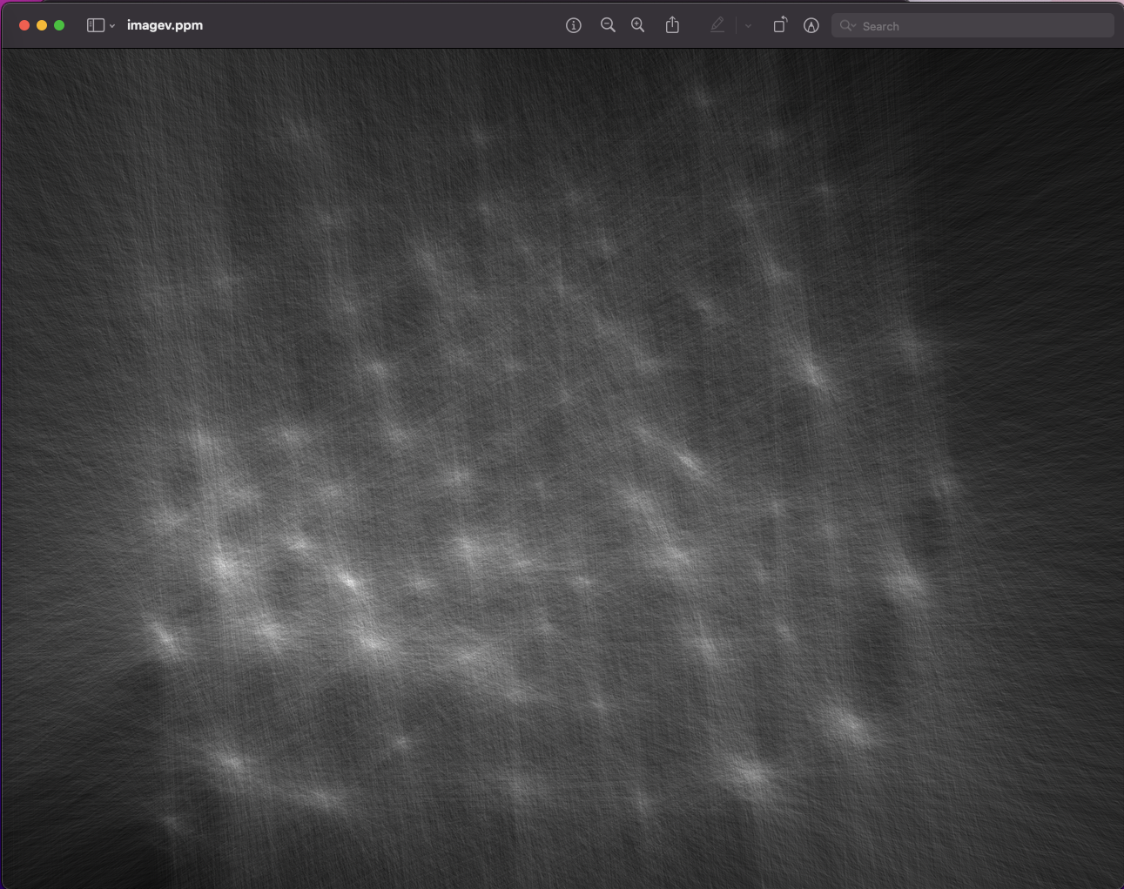

coinsppm:

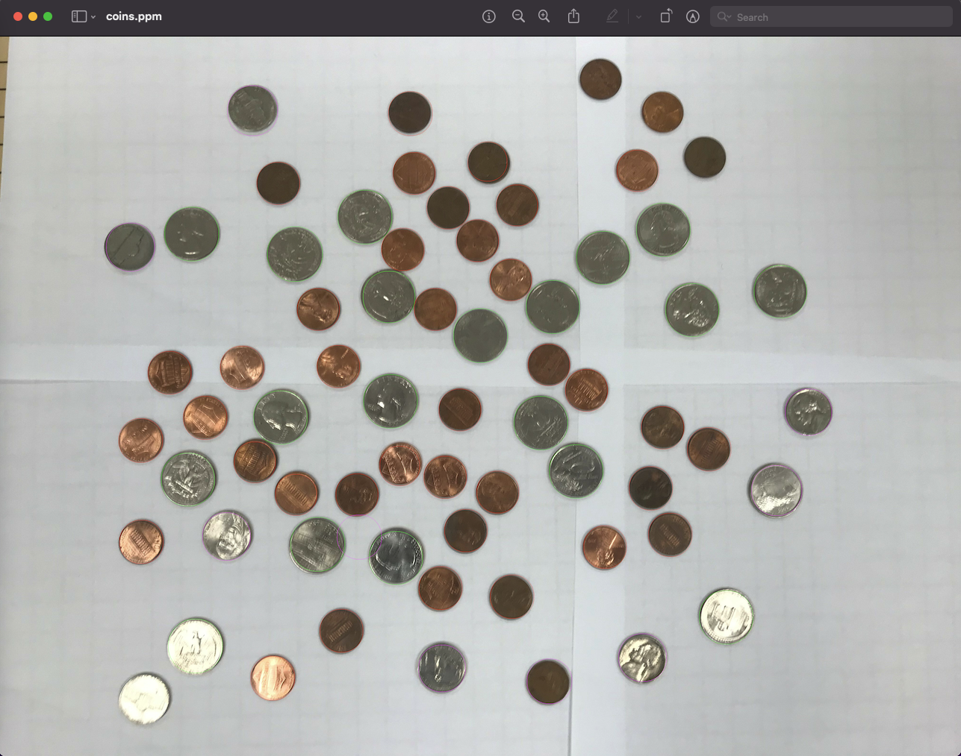

Content of results.txt:

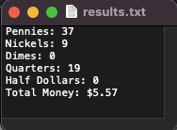

1. For the medium image:

Command line including all parameter values used for this image:

\l061 -L 70 -U 140 -TC 170 -F image.ppm -TCircle 0.18

Initial image:

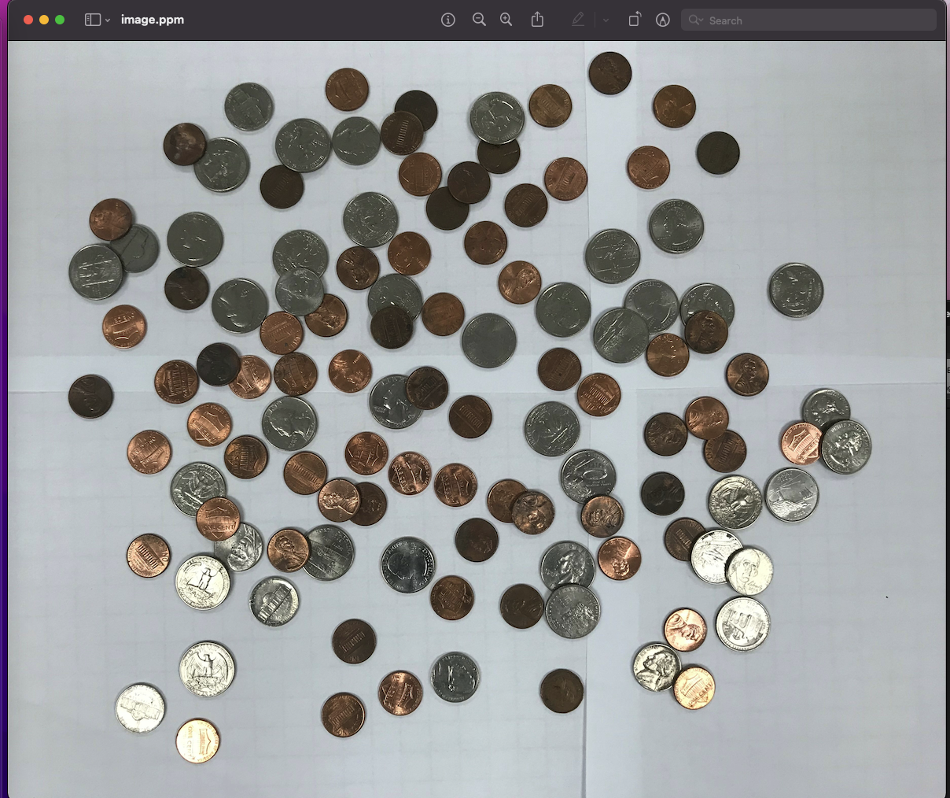

imagev.ppm:

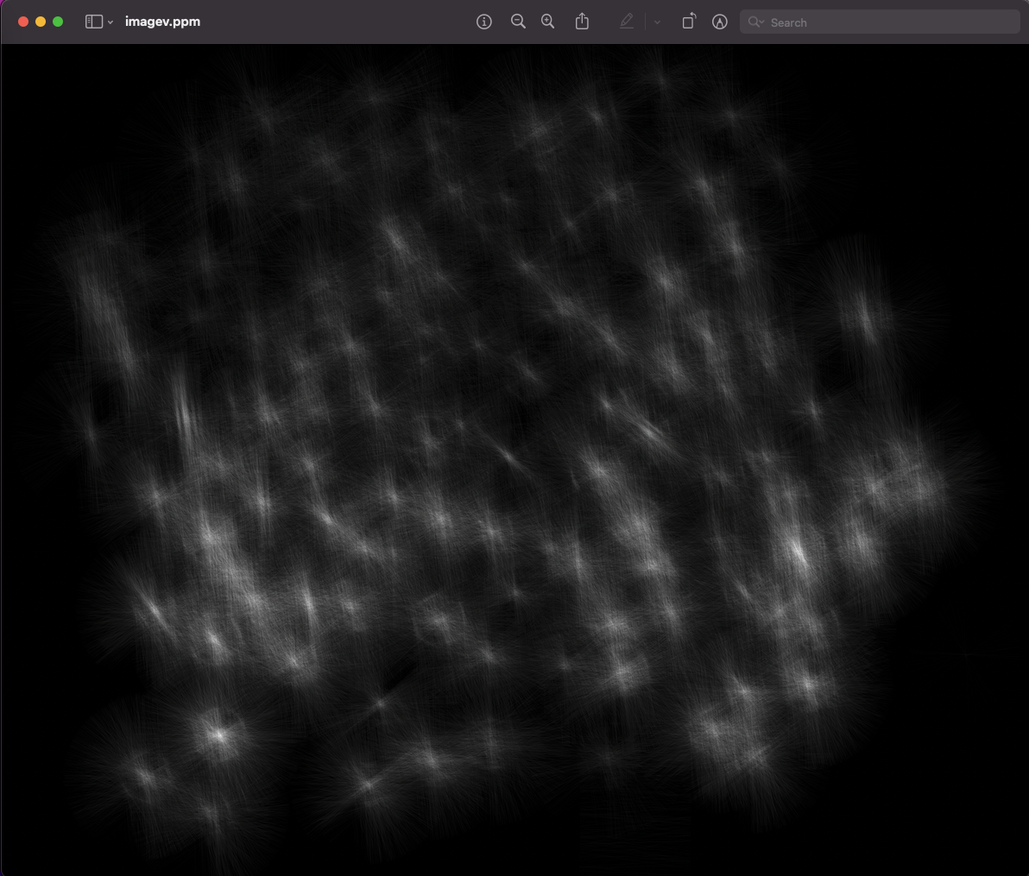

coinsppm:

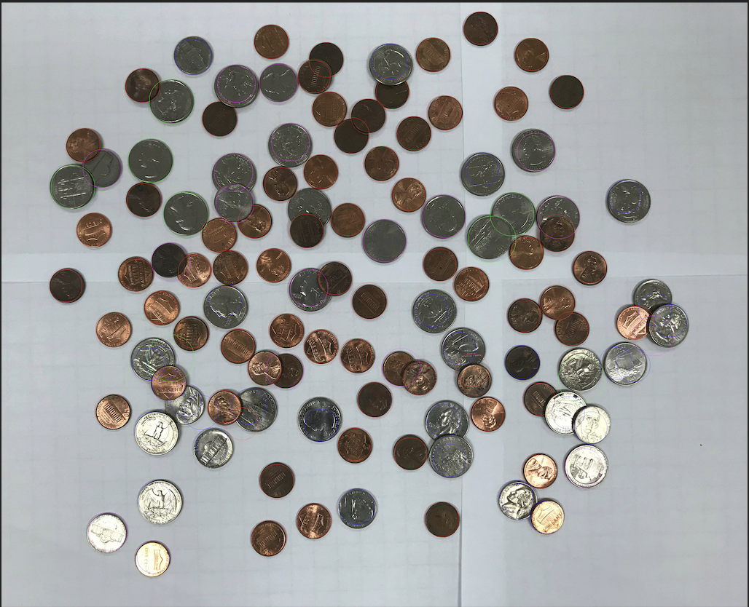

Content of results.txt:

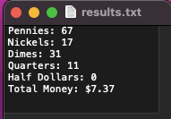

1. For the hard image

Command line including all parameter values used for this image:

\l061 -L 60 -U 120 -TC 170 -F image.ppm -TCircle 0.1

Initial image:

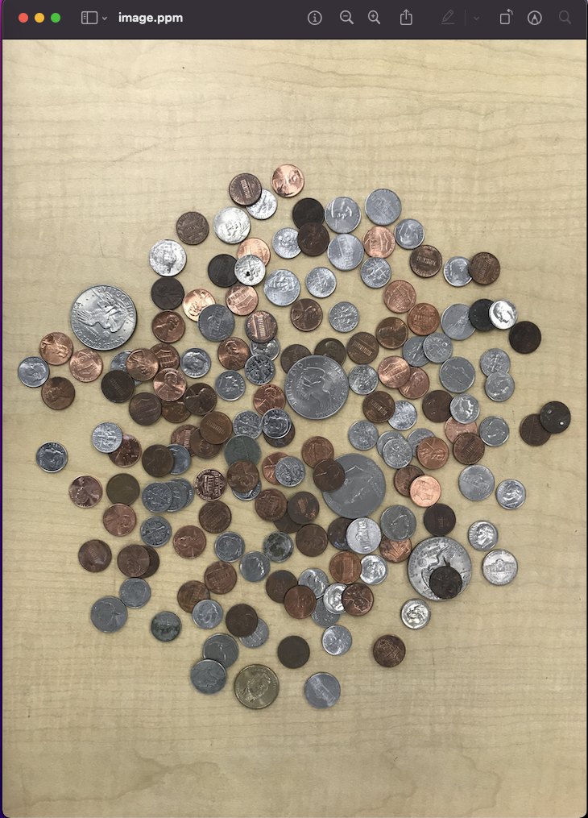

imagev.ppm:

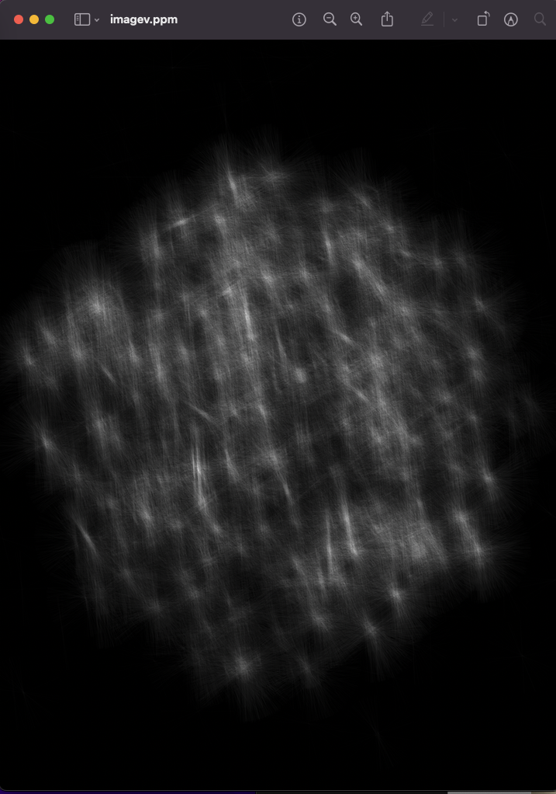

coinsppm:

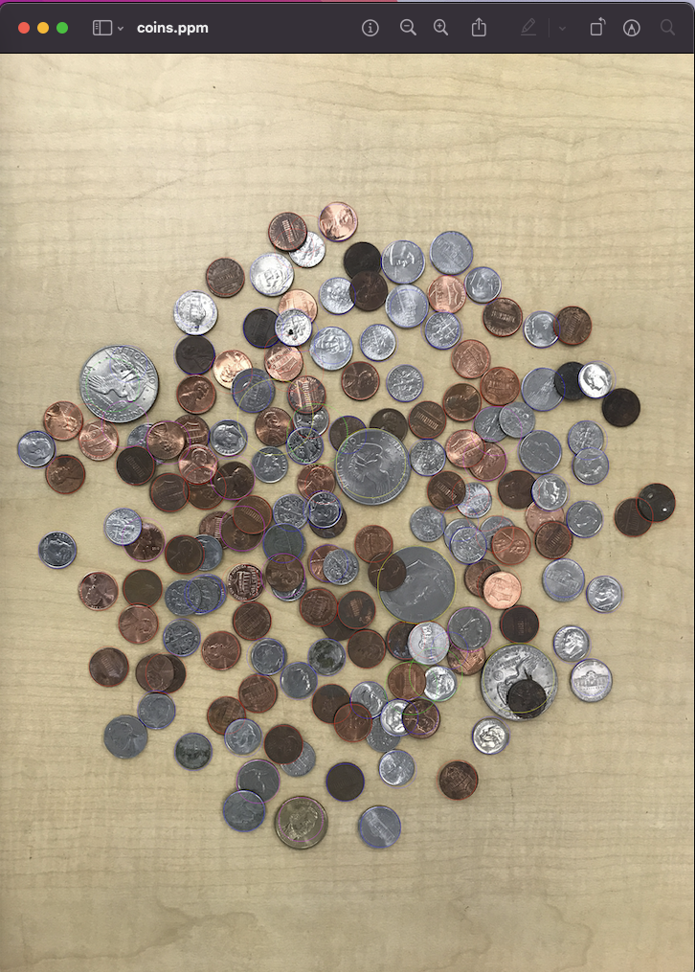

Content of results.txt:

